VIRGINIA UNION UNIVERSITY
Information Technology Center
Ellison Hall 116
ITC@VUU.edu | (804) 257-5630

MEMO FOR: New Employees

FROM: Information Technology Center

SUBJECT: Technology Accesses to MyVUU, Email, Emergency Notification System, Password reset tool, Support ticketing system, Phones, and VUU’s WIFI network.
Understanding how to access VUU’s technology is important!

MyVUU

Your MyVUU account login consists of your ID number and your PIN. Your ID number is found on your VUU ID. The IT Staff will be able to provide you with your PIN.

VUU Email Account
Your VUU Email Account will be activated once you present your VUU ID and Human Resources paperwork to the IT Staff.
Username and password are presented as follows:
Username: JLDouglass (First Initial, Middle Initial, Last name)
Email Address: JLDoeglass@vuu.edu
Password Requirements:
Password must be at least 8 characters long
Password must contain 3 out of 4 of following:
  - At least 1 uppercase letter
  - At least 1 lowercase letter
  - At least 1 number
  - At least 1 Special Character (!,@,#,$,<,>, etc.)

You MUST use your Panther Card (VUU ID) to release print jobs, photocopy, and to scan.
Switch your default printer to Secure Print on VUUPaperCut
ALL PRINT JOBS should be sent to the server and then released at the specific machines utilizing your card for secure print.
To register your card, please follow the below instructions:
- Swipe Card through the Reader located on the Machine
- When prompted, enter your USERNAME as your USER ID (The same username used for your email account. OMIT the “@vuu.edu” when registering.)
- Enter your password. This is also the same password you utilize when you log into your computer and email account. It is case sensitive so ensure that you type it correctly.

VUUWIFI
When connecting to VUUWIFI, use the same username and password used to log in your VUU Email Account (omit the @vuu.edu in your username).

To learn more about our technology visit: http://my.vuu.edu/ICS/Technology/
Direct all Technology related questions to ITC@VUU.edu or to the Help Desk at 804-257-5630.

.
ITC SUPPORT TICKETING SYSTEM

Submit a support ticket to request for service from the Information Technology Center

http://vuuhelpdesk2.vuu.edu/readydesk/customer/rdlogin.aspx

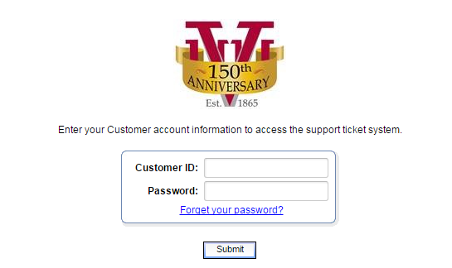

The Customer ID is your Username

For first time users, click on the Forgot your password link to setup your account Password.
Enter your VUU e-mail address to have your password automatically emailed to you. Once you have set up an account you will be able to login and track current and past tickets as well as open new support tickets.

Due to the volume of support requests we receive, we ask that you allow 5-7 business days for us to initiate your support request. All support requests are worked in the order they are received, unless any priority issues arise (server issues, internet issues, e-mail issues, network issues, etc.) .

VUU OFFICE PHONE
Voicemail set-up:
Press Messages (envelope button)
Enter default password: 525252
Enter new 6-digit password
Record Name (First and Last Name)
MyVUU directs you to everything you need to know about your office telephone and the Phone Web Portal system.

- Login MyVUU with your ID number and PIN.
- Click on the Phone and Printer Info tab.
https://my.vuu.edu/ICS/Phone_and_Printer_Info/

This page provides you with phone training, tutorials, quick tips, and information regarding our Phones.

The Phone Web Portal is VUU’s webpage that provides access to campus Directory, Call Management, and other Options.

To access the Web Portal

- Go to https://cloudvoip02.vox.icore.com/Login/
- Type your Phone Number in the User ID Field.
- Type your web portal password

User ID
Password
Remember Password

Copyright 2000-2012, BroadSoft, Inc.
This software and its documentation are protected by copyright law and international treaties. Unauthorized reproduction or distribution of this software,
or any part thereof, may result in severe civil and criminal penalties, and will be prosecuted to the maximum extent possible under the law.
BroadSoft and BroadWorks are registered trademarks of BroadSoft, Inc. Gaithersburg, MD
The programs included herein are subject to a restricted use license and can only be used in conjunction with this application.

VUU CAMPUS ALERT

Virginia Union University’s Emergency Notification System (ENS) is Text Messaging Service for Students, Faculty and Staff.

Virginia Union University offers an emergency alert text messaging service. This is an optional service that will be used only for potential, developing, or existing emergencies and advisories about Closings, Weather, etc. In the event of an Emergency you will receive a text message advising you of the situation. No advertisements. No gimmicks. No hassle. Just safety alerts and advisories when you need them.

**** Please Note that all VUU ENS messages will automatically be sent to your VUU email account****

To sign up for campus alerts there is a link at the top of the VUU Home Page https://www.vuu.edu/about-vuu/campus-police/emergency-alert-system

And another quick link is on the left side Quick Links menu when you login MyVUU

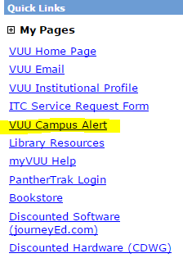
You may subscribe to the VUU ENS RSS feeds to receive ENS alerts through your news reader or your browser.

Campus Alert Frequently Asked Questions
Who can get VUU ENS Alerts?
The VUU ENS is designed for students, faculty and staff of Virginia Union University who will be affected directly by an emergency on the University Grounds and/or the proximate areas.

What do I need to get VUU ENS Alerts and how much does it cost?
You will need is a cell phone with text messaging capabilities. There is no charge to users for signing up. Individual cell phone plans will apply normal charges for the text message

Why should I get VUU ENS Alerts?
- Text messaging is more reliable in emergency situations when communication systems reach high capacity. Text messages will get through when phone calls won't.
- You will receive alerts anywhere, even when you do not have access to a computer.
What will the VUU ENS Alerts tell me?
A short text message will state the type of threat or the advisories and the suggested action.

How do I sign up for VUU ENS Alerts?
- To register, you need to have your cell phone handy.
- Login to the Signup page with your VUU email address (yorname@vuu.edu) and password
- Complete the online form. You will be asked to create your own user name and password. (Note: you may choose any user name and password for your VUU ENS account they are not your VUU Email address and password.)
- You will receive a text message in that will include 4-digit validation code.
- You must enter the validation code on the confirmation web page and hit the "Validate" button.
- You will then automatically be forwarded to a "Thank You" page.
The validate button also creates your own personal account where you will log in to update personal contact information.

Will my cell phone number be kept confidential?
Yes. VUU ENS cell phone numbers are not shared or sold to any other systems or services.

How many VUU ENS Alert text messages will I receive?
VUU ENS Alert text messages will be sent only to alert you to emergency situations in which there is an imminent threat to public safety. And advisories about Closings, Weather etc The exact number is difficult to predict, but there should be very few. You will receive messages within seconds of their transmission.

What if I change my cell phone service provider?
When you change cell/mobile phone providers but keep your existing mobile number it is considered "ported." Depending on the mobile phone provider, it may take up to 30 days for the VUU ENS to be updated. During the "ported" time period, you may not receive alerts because the alerts are sent to the old mobile provider, which may not forward them. You will find details on how to solve this problem and immediately register when you log on to get registration information.

What if I am not able to register?
For registration assistance, e-mail your mobile phone number and the name of your provider to ITC@VUU.edu from your VUU email account. Indicate you want to register for the Virginia Union University’s Emergency Notification System.

How can I opt-out of VUU ENS?
You can opt-out (discontinue) at any time just as quickly and easily as you signed up.
Login to your VUU ENS Account for and unsubscribe. Or send an email to ITC@VUU.edu with the request
Adding Email To your Phone
IPhone/Android

Instructions for your specific phone:
Login to https://mail.vuu.edu navigate to options in the upper right corner of the page and Select See All Options; on the right hand side select Learn how to get direct push e-mail on your mobile phone. In the Learn About E-Mail on a Mobile Phone section; click on Mobile Phone Setup Wizard; Choose your mobile phone operating system from the dropdown list. In the- What would you like to do? Dropdown list choose; Set Up Exchange E-Mail on an (your device type). Follow the Instructions / Video.

Basic settings
1: Open settings app
2: Select “Mail, Contacts, Calendars”/“Accounts”
3: Select Add Account
4: Choose the Microsoft Exchange option
5: Enter your information in the Email and Password box
(If it doesn’t complete then continue with step 6)
6: In the Domain box enter vuu.edu
7: In Server enter mail.vuu.edu
8: Enter in username without @vuu.edu
If entered correctly it should ask you to activate and sync information.

FORWARDING EMAILS:
When you log into the outlook web app. (mail.vuu.edu) click on options - (top right side) choose see all options / organize E-Mail / inbox rules / select NEW rule
In the new Rule box:
under *When messages arrives, and: select [Apply to all Messages]
Under the Do the following: select Redirect the message to… then at the bottom of the pop up window in under Message recipients: enter the email address you want to forward to in the To -> the box. / click ok / click save / click yes / click yes

How to Enroll with the VUU Password unlock / password reset tool (ADSelfService tool)
Enrollment is a simple registration process wherein you provide some information about yourself which is used to validate your password reset or account unlock requests. For more details, refer , how to reset your password or unlock your account.

The Enrollment Process:
- Enrollment using security questions & answers
- Enrollment by verification code
- Enrollment using Google Authenticator
You can enroll with ADSelfService Plus using your mobile device too. Click here to know how.
How ADSelfService Plus verifies your identity?
You can choose any one of the following methods of enrollment.
- Security Questions & Answers: During enrollment, you either choose from a set of predefined security questions or write your own security questions, and provide the corresponding answers. In future when you need to reset your password or unlock your account, ADSelfService Plus will ask you these questions. ADSelfService Plus will authenticate your identity using the answers and then allow you to reset the password or unlock the account.
- Verification Code: While enrolling with ADSelfService Plus, you will be asked to provide either your mobile number or email address. Whenever you request for a password reset or account unlock, ADSelfService Plus will send you a verification code to the registered mobile number or email ID. You will have to enter this code into ADSelfService Plus to reset the password or unlock the account.
- Google Authenticator: During enrollment, you will have to configure the Google Authenticator app with ADSelfService Plus. When you try to reset your password or unlock your account, you will be asked to enter the 6-digit security code generated by the Google Authenticator app to verify your identity.

Enrollment using Security Questions and Answers
- Start and logon into ADSelfService Plus with your domain credentials.
- Click on the "Enrollment" tab.
- Select the "Security Questions & Answers" tab.
- At this stage, you will be provided with any or all of the following options (depending on your IT administrator’s choice):
- Answering to an already configured security question(s)
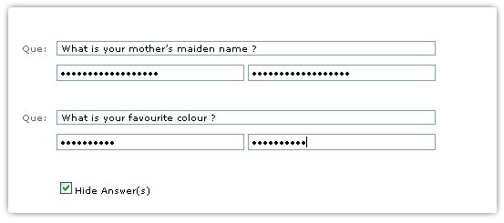

- Selecting a Security Question(s) from a list and answering them
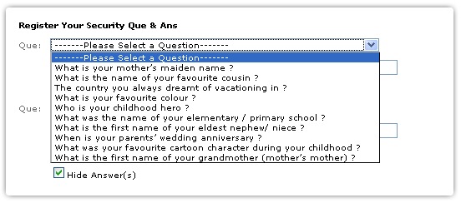

- Writing your own Security Question(s) and answering them
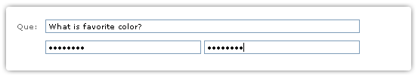
- Once you have answered security questions, hit the ‘Save’ button.

You will now get a message stating that your enrollment process was successful.

Password Reset. Q and A
Is this for faculty or students or both?
Both, the self-service password reset tool is for all current VUU Students, Faculty, and staff access accounts.

Will this feature allow us to unlock the “frozen” account?
Yes, you can unlock locked (frozen) accounts once enrolled.

What if one is abroad and can’t access one’s VUU account because it is locked?
You will have the control to unlock your VUU access account or change your password 24 hours a day 7 days a week from a web page portal or from your smart phone APP (Apple or Android) once enrolled.

What is the webpage address?
A link to the portal is on the VUU Web Mail login page, My.VUU pages and VUU domain computers.

Do I have to still have to bring my VUU ID card to the Technology Center to have my password reset?
No, you will no longer be required to bring your VUU ID card to the IT center to verify your identity to have your password changed once enrolled.

How do I get the APP?
Once enrolled click on the “Self Service” tab then click the “Mobile Access” button at the top right of page. There will be 3 QR codes:
Step-1 Scan the Apple or Android QR code from the top line to download the mobile app.
Step-2 Scan the bottom QR code to automatically configure the app with your account information.

